**Contents**

Inheritance & Polymorphism

[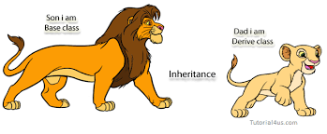](https://www.google.co.in/imgres?imgurl=http%3A%2F%2Fwww.sitesbay.com%2Fjava%2Fimages%2Finheritance%2Finheritance-example.png&imgrefurl=http%3A%2F%2Fwww.sitesbay.com%2Fjava%2Fjava-inheritance&docid=JZlodgPWubH2iM&tbnid=L8ds__74Py-D7M%3A&vet=10ahUKEwja1Y3KsI_VAhVIipQKHUpHCJ0QMwhoKBUwFQ..i&w=619&h=257&safe=active&bih=517&biw=898&q=inheritance%20in%20java&ved=0ahUKEwja1Y3KsI_VAhVIipQKHUpHCJ0QMwhoKBUwFQ&iact=mrc&uact=8)Inheritance:

* Child class (sub class) automatically inherits the variables and methods defined in its parent class (super class).
* This allows to reuse existing class members and make them extendible either for enhancement or alteration.

[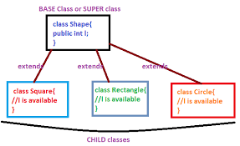](https://www.google.co.in/imgres?imgurl=http%3A%2F%2F2.bp.blogspot.com%2F-za_vt5MwvaI%2FVAnDzFeL8sI%2FAAAAAAAAAeg%2F-N7H3HgH6qs%2Fs1600%2Finheritance1.png&imgrefurl=http%3A%2F%2Fjavalanguageprogramming.blogspot.com%2F2014%2F09%2Finheritance-in-java.html&docid=JKng1fHQw0334M&tbnid=m8ASkgKTd7P9cM%3A&vet=10ahUKEwja1Y3KsI_VAhVIipQKHUpHCJ0QMwiPASg8MDw..i&w=595&h=364&safe=active&bih=517&biw=898&q=inheritance%20in%20java&ved=0ahUKEwja1Y3KsI_VAhVIipQKHUpHCJ0QMwiPASg8MDw&iact=mrc&uact=8)

**Extends keyword :**

class Base { //code }

class Derived **extends** Base { //code }

super

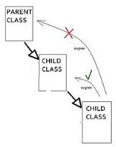It is a reference variable used to refer the immediate parent class object

* super() invokes immediate parent class constructor
* Call member (variables & methods) of parent class

**Syntax :** super.baseclassMemberName

Overloading & Overriding

|  |  |
| --- | --- |
| Overloading (compile time polymorphism) | Overriding (run time polymorphism) |
| Two or more methods within the same class share the same name but parameter declarations are different.  You can overload Constructors and Normal Methods. | A method in a subclass has the same name and type signature as a method in its super class, then the subclass method overrides the super class method.  Overridden methods allow Java to support run-time polymorphism |

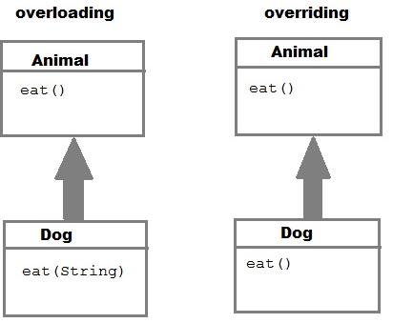

[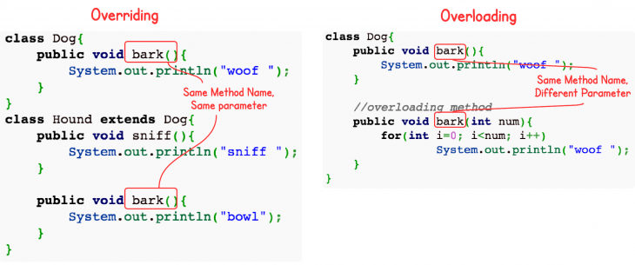](http://www.google.co.in/url?sa=i&rct=j&q=&esrc=s&source=images&cd=&cad=rja&uact=8&ved=0ahUKEwjgi_Gkto_VAhVMFpQKHZhjD90QjRwIBw&url=http%3A%2F%2Fwww.programcreek.com%2F2009%2F02%2Foverriding-and-overloading-in-java-with-examples%2F&psig=AFQjCNErVHu74iwipTqt8kxuCTJPdkDmoA&ust=1500350159031813)

final

* Restrict changing value of variables
* Restricts inheritance. Therefore, restricts method overriding

